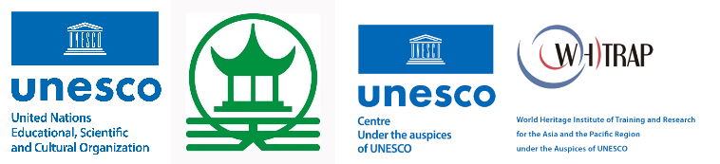

2026亚太地区世界遗产青年营造师
2026 Young Masters for Heritage Conservation

附件2：项目描述指南
ANNEX II: PROJECT DESCRIPTION GUIDELINES

请用中英文填写此表，并置于PDF 首页。每个项目单独附表。
Please complete this form in Chinese and English and put it on the front page of the project description in PDF.
项目名称/Name of the Project
项目对应遗产的名称和地址/Name and Address of Heritage Property | （名称、街道、城市、省份、国家）  (Name, Street, City, State, Country)
遗产类型/Type of Heritage Property
项目规模（建筑面积 平方米）/Scale（GFA sq.m. ）
开始和建成时间/Start and Completion Date
项目概况/Introduction of Project | 简要描述项目内容及其创新性。（500字以内）。  Abstract-brief introduction and its innovation of project (within 500 words).
申请人的角色和贡献Role of Applicant in the Project /Contribution of Applicant to the Project

项目描述指南（within 3500 words）
Project Description Guidelines（within 3500 words）

您参考以下指南进行项目描述：
Please follow the guidelines for the project description:

- 项目背景(500字以内）
Project Background（within 500 words）
项目的起源与动机（如气候适应、城市化影响、文化传承、生物多样性保护、遗产活化需求等）；
- Origin and motivation (e.g., climate adaptation, urbanization pressure, cultural inheritance, biodiversity conservation, heritage revitalization needs);
项目总体目标（聚焦历史园林活态保护与社区参与等）；
- Goals expected to achieve (focusing on living conservation of historic garden and community engagement);
提供项目执行时间表及完成周期；
- Timeline and completion cycle;
项目规模；
- Project scale;
项目支出（人民币/美元）与资金来源。
- Project cost (RMB/USD) and funding sources.

- 遗产地描述 (500字以内）
Heritage Description（within 500 words）
项目涉及遗产的历史背景、本土价值与区域 / 全球意义；
- Historical context, local significance and regional/global value of the heritage;
遗产与周边社区、公众生活的关联；
- Relationship between the heritage and surrounding communities/public life;
对现场和周边环境的调查与研究；
- Investigation and study on the site and its surrounding environment;
当前遗产保护面临的主要挑战。
- The main challenges currently facing the heritage conservation.

- 项目如何符合评选标准 (2500字以内）
Alignment with Selection Criteria （within 2500 words）
（请对照以下5 项标准逐一阐述，可合并或分点说明）
(Elaborate against the 5 criteria below)

1、文化与自然融合Integration of culture and nature
项目应体现与2030年可持续发展目标的一致性，特别是在气候适应性、生物文化多样性保护及可持续资源管理方面。
Projects should demonstrate integration approaches to the conservation of cultural and natural values, in alignment with the 2030 Sustainable Development Goals, including in relation to climate resilience, biodiversity conservation, and sustainable resource management.

2、传统知识的保护与传承Conservation and transmission of knowledge
项目应体现对传统园林设计理念、传统营造技艺、园艺实践及文化景观遗产价值的深刻理解，同时探索其保护与传承的创新方法。
Projects should reflect a solid understanding of traditional garden design principles, craftmanship, horticultural practices, and any other heritage values, while exploring innovative approaches to their safeguarding and transmission.

3、创新与创造力Innovation and creativity
项目应展示其在设计、阐释或保护管理方面的创新方法，包括融合当代实践、数字工具或艺术方法。
Projects should demonstrate innovative and creative methods in design, conservation, interpretation, or management, including the appropriate use of contemporary practices, digital tools, or artistic interventions.

4、社会影响 Social impact and public engagement
项目应积极吸纳社区居民和游客参与，提升对历史园林的认知度、参与度，并推动形成共同保护意识，确保保护事业的可持续性与代际传承。
Projects should foster community participation, enhance public awareness, and promote shared stewardship of garden heritage.

5、地域文化与可复制性 Relevance and replicability
项目应展示与地域文化的关联性，并具有一定在其他遗产环境下的适用性，促进更广泛区域内历史园林的对话。
Projects should demonstrate strong relevance to local cultural context while offering potential for adaptation or replication in other heritage settings, contributing to broader regional and international dialogue.

